**PYTHON ASSIGNMENT 3**

**Q1) Make use of Time Module and for Loop**

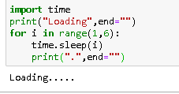

**Q2) Difference Between Return and Yield**

|  |  |
| --- | --- |
| **Return** | **Yield** |
| sends a specified value back to its caller | Produce Sequence of values |
| Used to exit from a frunction or block of code | Used to define generators |
| Returns 1 value and clear state of variable | Returns the Value and Save the Position |

**Q3) Make digital clock and Run it for 5 sec**

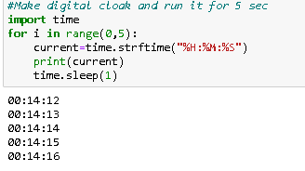

**Q4) Add anything in tupple. Example (1,2,3,4)-> (1,2,3,4,5)**

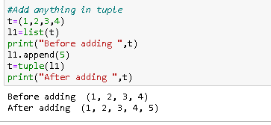

**Q5) Whatsapp texting using Webbrowser Lib**

import webbrowser

import time

for i in range(1,20):

if time.ctime().split(" ")[3]=='18:21:2':

webbrowser.open("https://wa.me/0002000000")

else:

time.sleep(1)

print(time.ctime().split(" ")[3])